* Go to AWS console and create a instance .

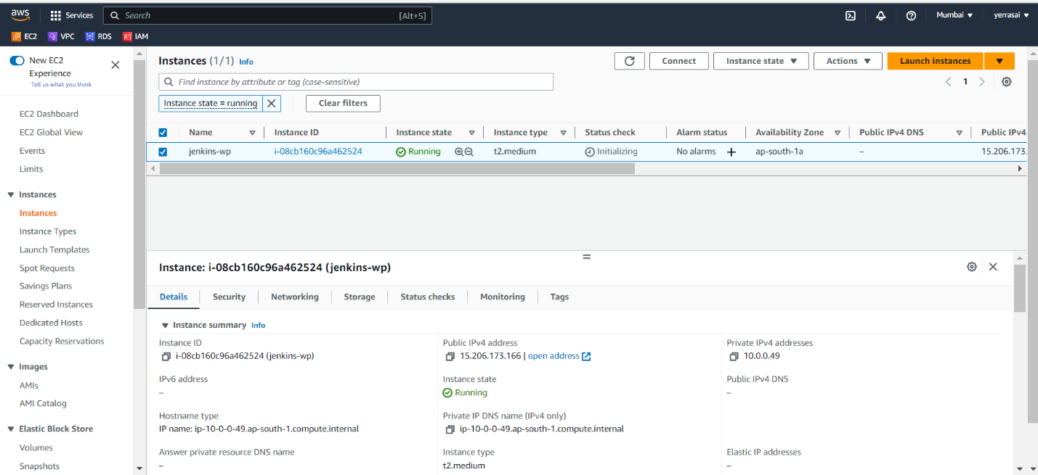

* Connect to instance by using terminal .

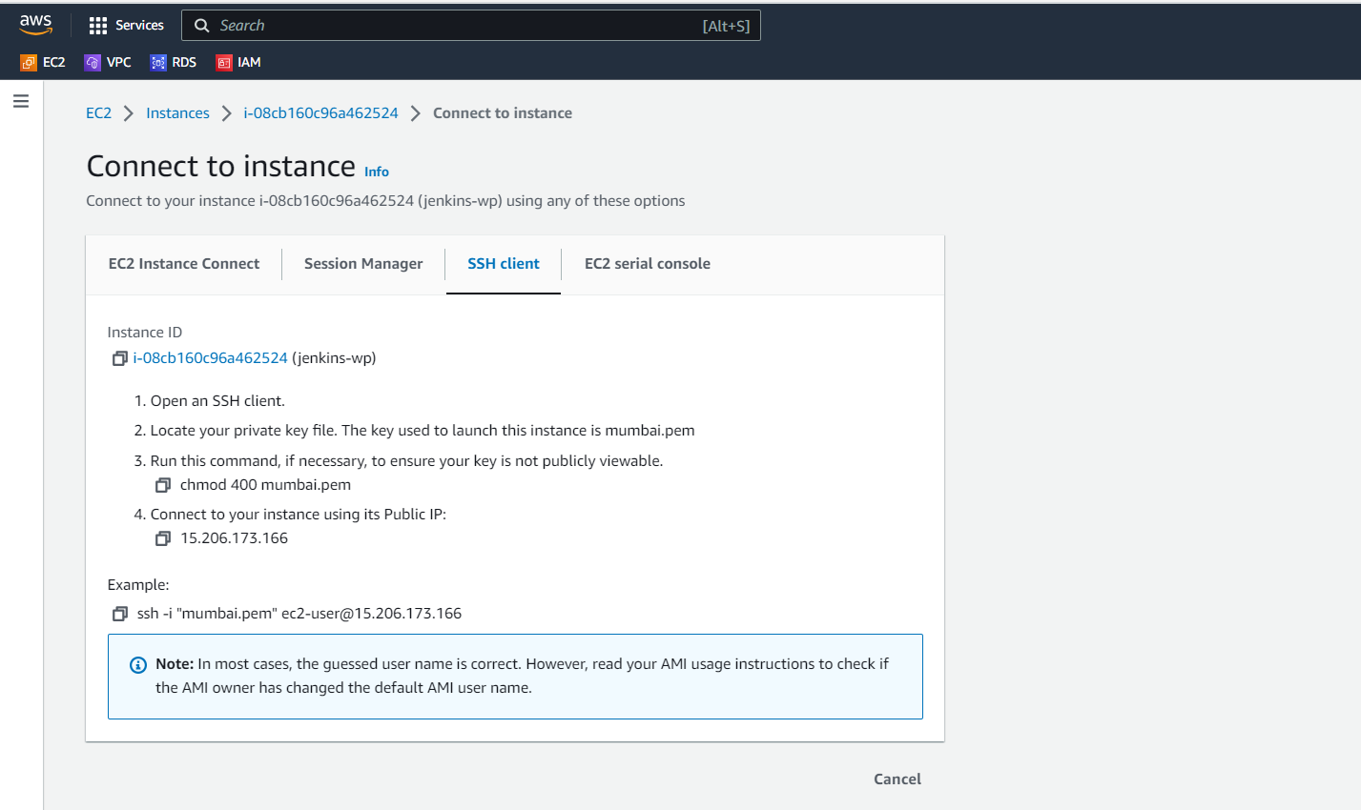

* Go to terminal and copy the ssh key in where the pem.file located.

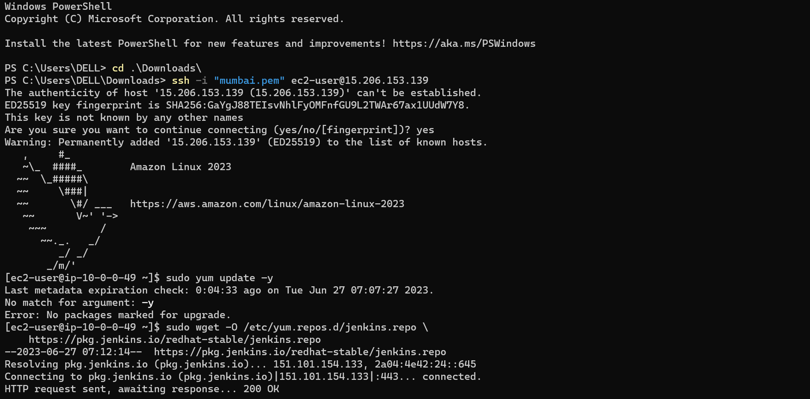

* Install Jenkins packages by using commands.

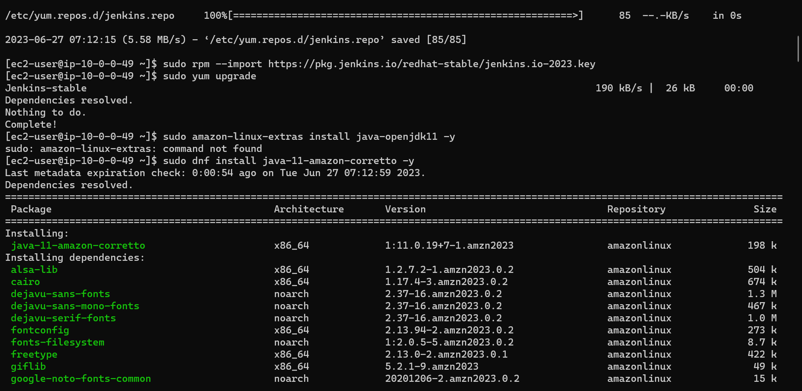

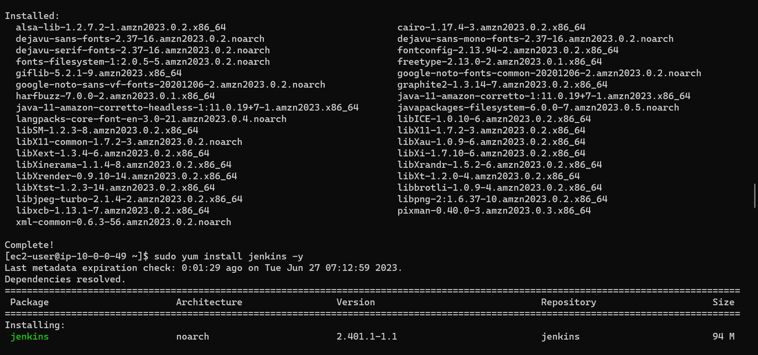

* After installation of Jenkins, we have to give permission to access jenkins.
* Change directory to etc and give ls command to see the files.
* Sudo vi sudoers.

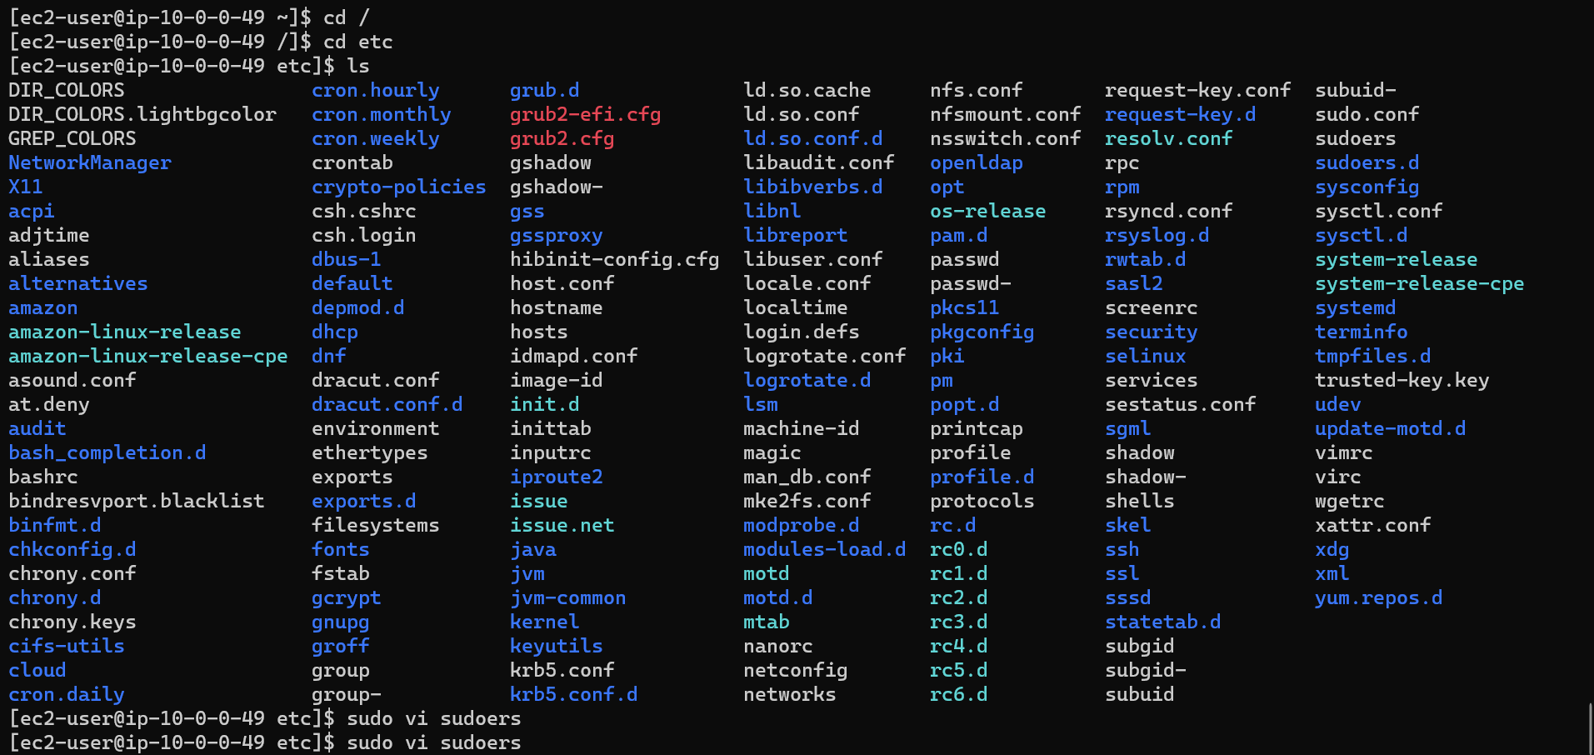

* Here we have given allow Jenkins to run any commands.

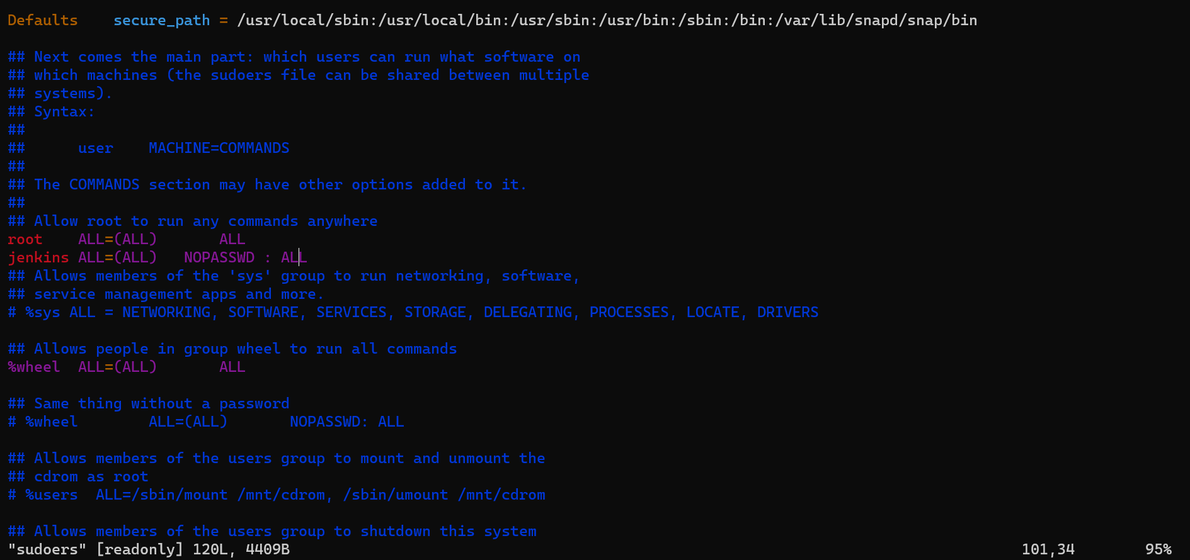

* Log in to jenkins console and create a job by using freestyle job and make configure.

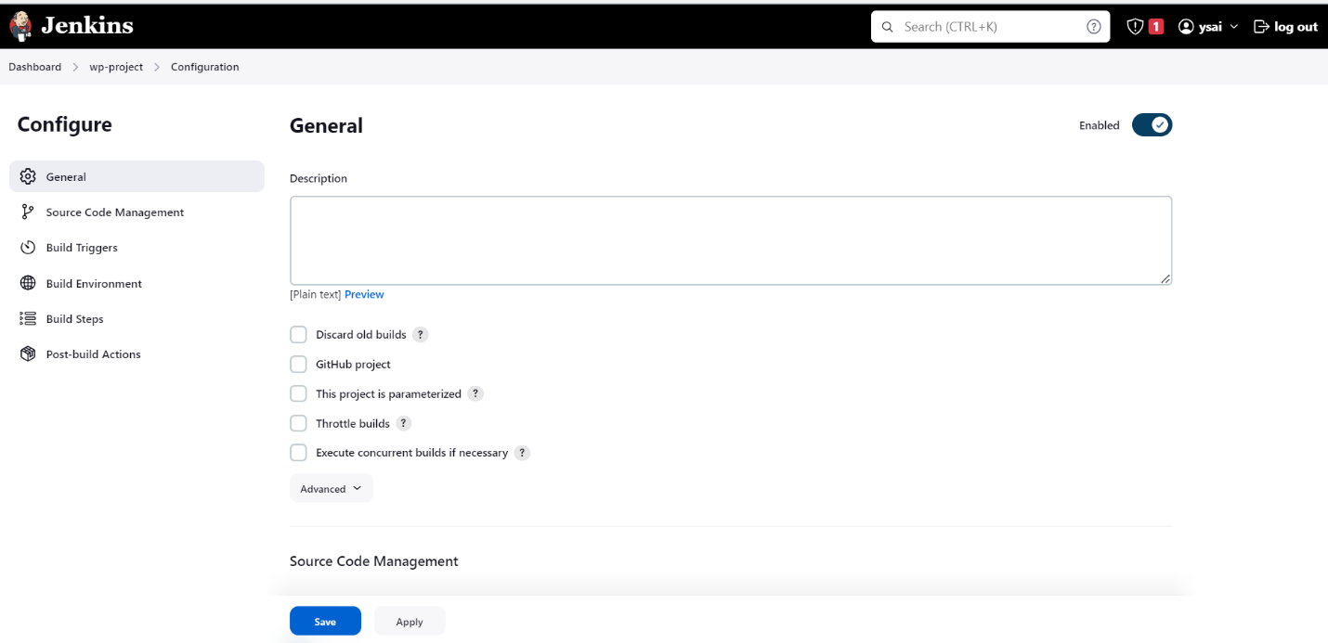

* Here we give git URL to clone the file .

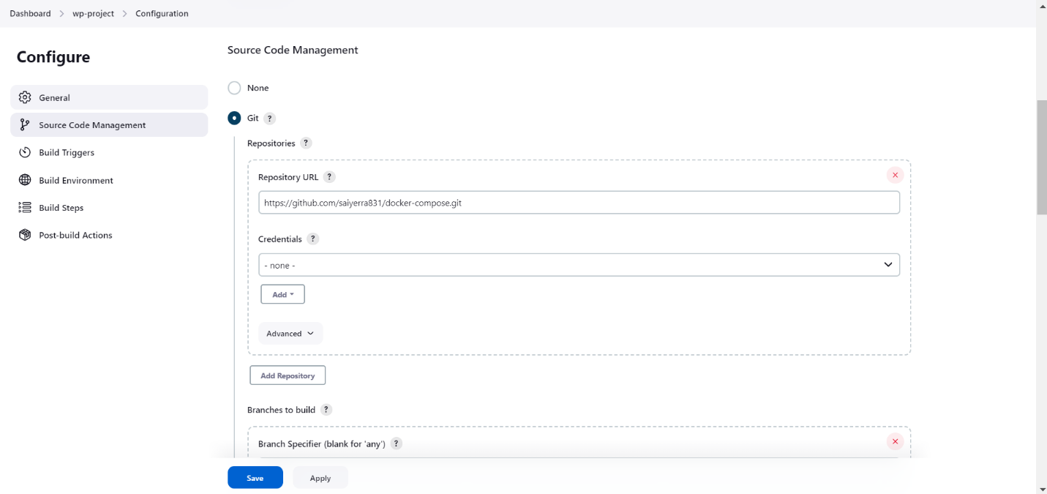

* In execute shell we have mention all the commands what we are assigning.

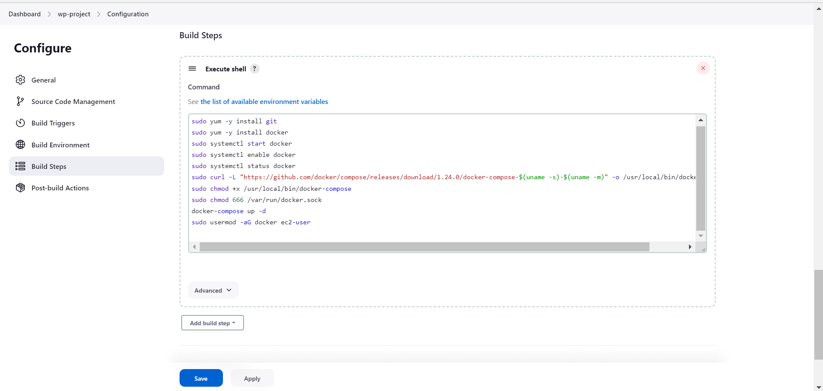

* After writing the execute shell we have to apply and save.
* Now, we have to build the job.
* If the console is succesful then see the output by using ip address.

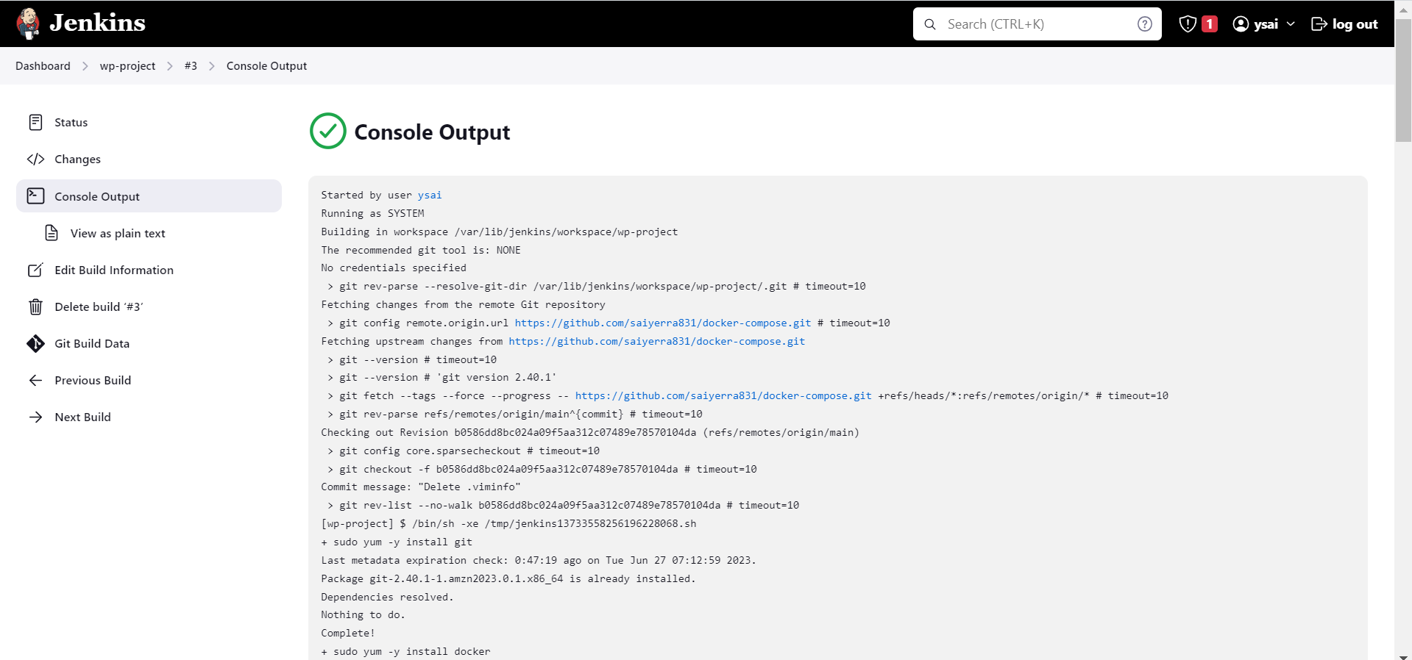

* This is output of WordPress via Jenkins by AWS.

